# Tutorial 01 – Introduction

Today's tutorial is designed to get you familiar with using the IDLE Python shell and editor and starting to write some Python commands.

IDLE should be installed in all the tutorial labs: QM269, D264, QA274 and all the 2nd & 3rd floor labs in King William. In other labs you may need to visit the University’s software centre to install it first.

See how many of the following exercises you can do WITHOUT looking at the lecture notes. If you get stuck FIRST look at the lecture notes and if still can’t find the answer THEN ask your lab tutor. (Your tutor is more than willing to help but you should get into the practice of trying to out information for yourself.)

1. Start up IDLE (on a PC, hit the windows key and start typing IDLE).
2. What is 97 times 43? Use the Python shell to calculate the answer.
3. Print the words “Hello Greenwich!” in the shell.
4. Create a program which prints the words “This is my first program”. Save it in a file called FirstProgram.py
5. Create some Turtle graphics programs in appropriately named files. Try to draw:
   1. a rectangle
   2. two squares side by side (but not touching) – try to use exactly the same code to draw each square
   3. a triangle
   4. a yellow house with a red roof (a square with a triangle on top – don’t bother with windows and doors!)
   5. an orange hexagon with thick purple sides
   6. if you found those all really easy, try experimenting with the circle command to draw something interesting

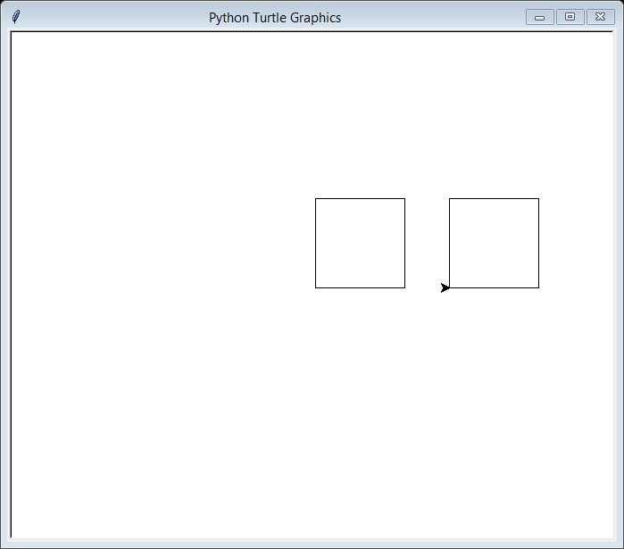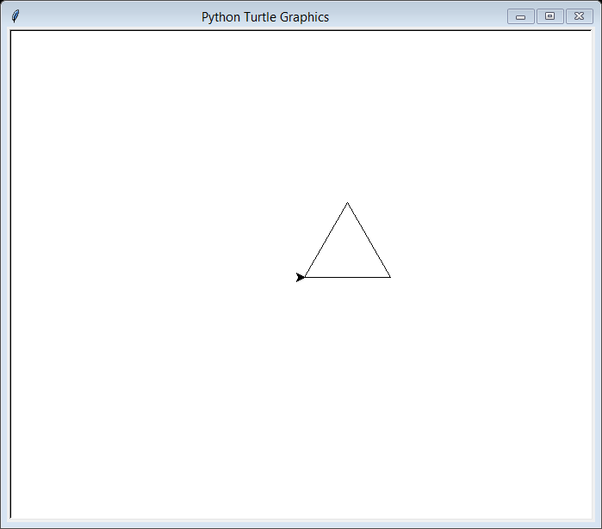Your designs may look like these:

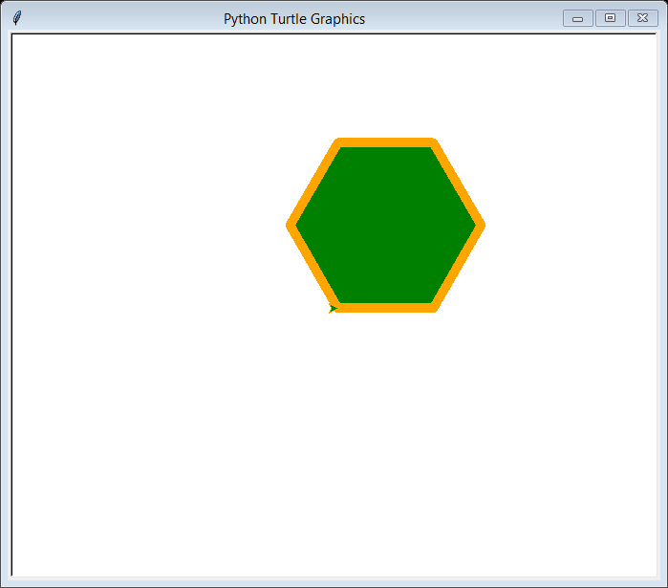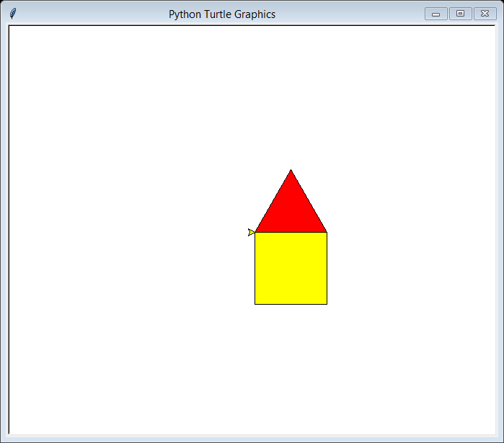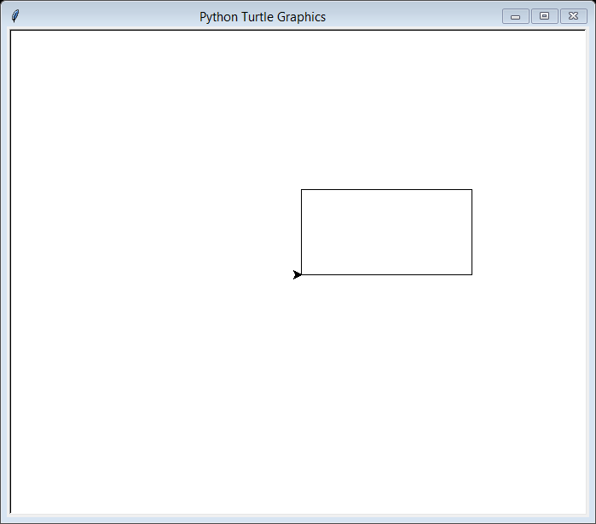

PTO – there’s more!

1. When you get home (or if you have a laptop with you) install Python on your own computer. You will need to visit [python.org](https://www.python.org/) and download an appropriate version (PC / Mac / etc).

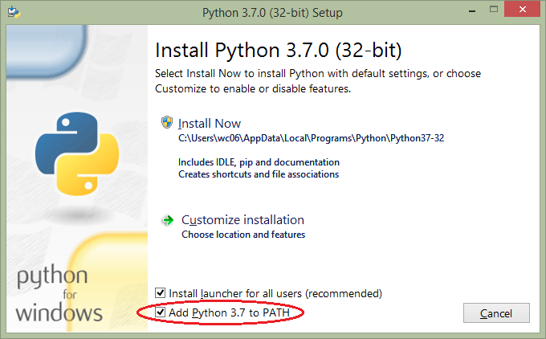When you install it, make sure the box which says “Add Python 3.x to PATH” is checked (by default it isn’t, which means that Python won’t work fully ☹).

Try some of the examples out to make sure it is working (NB 07ImageFilters.py won’t work without an additional installation, so don’t try that one).